Lab 3.4 Identifying genotypes of Salk-line plants, revised

Goal for this lab:
Set up PCR to determine the genotypes of Salk line plants to identify homozygous mutant individuals.

Introduction:
Today you will use a PCR-based strategy to determine the genotype of each of the individual plants from your Salk line populations. The strategy for genotyping depends on the fact that the mutant allele has a T-DNA sitting in the middle of the gene, while the WT allele does not. Thus, the gene-specific primers that you designed (illustrated below as GSP1 and GSP2) will only amplify a fragment from the WT allele. The mutant allele cannot be amplified with such a primer set, because the T-DNA is far too large to amplify. However, if we use a T-DNA-specific primer that is located near the left border of the T-DNA (LBP), it plus one of your gene specific primers will amplify a fragment from the mutant allele. (See the illustration on page 145.)
In the Salk line plants that you are growing, you expect to find all homozygous mutants. Unfortunately, sometimes errors occur, and you will actually have a mixed population containing homozygotes (both for the mutant allele and the WT allele) and heterozygotes. By using both primer sets discussed above on each individual, we can determine the genotype of each individual plant. The reasoning for this illustrated below.
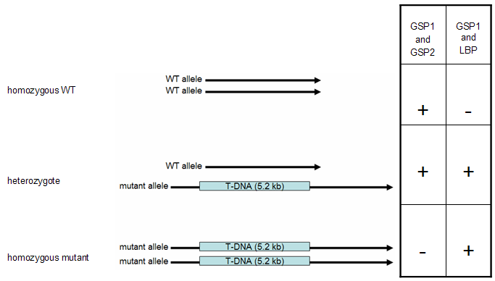
As you can see above, a DNA template prepared from a homozygous WT plant will be amplified using the primer combination GSP1 + GSP2, but will not be amplified by the GSP1 + LBP combination. Only heterozygotes will produce an amplified fragment using both primer sets, because only they contain both alleles.
When visualizing this on a gel, we would see something like the gels illustrated on the following page. In the top gel, we have loaded PCR reactions that used the primer combination GSP1 and GSP2, which only amplifies WT alleles of the gene of interest. Separate reactions were performed on DNA from each individual from the Salk line (1-10) and from a WT control individual (WT). In the bottom gel, we have loaded PCR reactions that used the primer combination GSP1 and LBP, which only amplifies mutant alleles of the gene of interest. As before, separate reactions were performed on DNA from each individual from the Salk line (1-10) and from a WT control individual (WT). Using the two gels, we can “read” the genotype of each plant. Consider the two gels illustrated below as an example.
GSP1 + GSP2 Primer set | 1 2 3 4 5 6 7 8 9 10 WT
GSP1 + LBP Primer set | 1 2 3 4 5 6 7 8 9 10 WT
In this example, plant 1 is homozygous for the WT allele, and plant 3 is a homozygous mutant. Plant 2 is heterozygous. The WT control is homozygous for the WT allele, as expected. Practice reading the genotype of the rest of the plants above.

Today’s Tasks

Materials:
Retsch Mixer Mill MM400Metal beads
Sterile ddH₂0
Working stocks of primers for each group diluted at 12.5 μM
Reagent | conc |  |  | pH | also known as
DEB  (DNA Extraction Buffer) | 100  50  25  1  10 | mM  mM  mM  %  mM | NaCl  Tris  EDTA  SDS  BME | 8.0 | Sodium chloride  trishydroxymethylaminomethane  Ethylene diamine tetra-acetid acid  Sodium dodecyl sulfate  β-mercaptoethanol
T₁₀E₅ | 10  5 | mM  mM | Tris  EDTA | 8.0
T₁₀E₁ | 10  1 | mM  mM | Tris  EDTA | 8.0
EtOH | 95 | % |  | - | Ethanol
EtOH | 70 | % |  | - | Ethanol
ISOP | 100 | % |  | - | Isopropanol
KOAc | 5 | M |  | - | Potassium acetate (CH₃COOK)
NaOAc | 3 | M |  | 5.2 | Sodium acetate (CH₃COONa)
LN₂ |  |  |  |  | Liquid nitrogen

Methods
Before you begin, read through the directions and get everything out that you will need so you don’t have to fumble for it in the middle of some critical step in the extraction procedure.
SAFETY: LN₂ is very very cold, –320° F (–196° C), and will severely damage tissue that it contacts! Use extreme caution while handling to avoid freezing injuries.

First task: Design PCR reactions.
The first order of business is to decide on your primer sets. The GSP1 + GSP2 set is easy—you designed those primers during Lab 4.2, and they should amplify the WT allele of your gene. The primer set that will amplify the mutant allele of your gene needs consideration. You will be provided with the primer oLBP, which primes DNA synthesis OUT of the LEFT BORDER of the T-DNA. You must decide whether to use your left or right GSP primer. In the example, below, the left border of the T-DNA is at the left side, and so the appropriate GSP was GSP1. Your T-DNA may be oriented the other way, in which case you would need to use the equivalent of GSP2 in the examples below. Thus, the orientation of the T-DNA within your gene of interest suddenly matters a lot. You and your lab partner need to think this through carefully before proceeding.
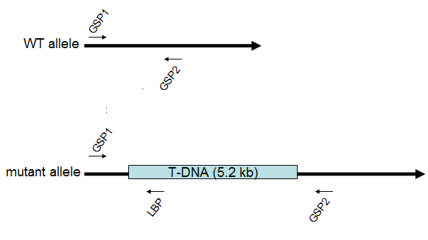
Primer Set | WT allele | T-DNA mutant allele
GSP1 + GSP2 | amplification | no amplification
GSP1 + LBP | no amplification | amplification

Second Task: Choose Salk plants to genotype
You will need DNA from 11 Salk plants. Pick those whose genotypes you most wish to know. This may be any combination of seedlings grown on soil or on plates.

Third Task: Prepare template DNA from plants
- Label 13 1.5 mL microfuge tubes:
  - 1 for a WT (Cl0) plant grown on soil,
  - 1 for a WT plant grown on a plate,
  - 11 for the Salk seedlings you have chosen to sample
- Add 2 metal beads to each labeled 1.5 mL tube and pre-cool the tubes by placing in liquid nitrogen (LN₂).
- Cut 2 leaves per plant and immediately move them into the 1.5 mL tubes placed in LN₂. Close the tubes, and keep them in liquid nitrogen. Do not let the tissue thaw once it is frozen.
- We will use the Retsch Mixer Mill MM400, a ball mill, to pulverize the frozen leaf tissue into a fine powder. This essentially works in the same manner as disrupting the tissue with a mortar and pestle, as previously in Lab 1.1, while allowing us to work with a smaller amount of plant material.
- Quickly, without letting the tissue thaw, move the 1.5 mL tubes from LN₂ into pre-cooled white blocks for the ball mill.
- Shake the blocks in the ball mill for 1 minute, and immediately place tubes back onto LN₂.
- Add 600 μL DEB (DNA Extraction Buffer) and mix vigorously by vortexing.
- Incubate the tubes at 65°C in a dry bath for 10 minutes.
- Place the tubes on ICE and add 250μL 5M KOAc. Mix well by inverting the tubes repeatedly. Incubate ON ICE for 20 minutes.
- Centrifuge at maximum speed for 7 minutes 4°C.
- Remove your tubes from the centrifuge and notice the pellet consisting of tissue debris and precipitated protein. REMEMBER, you are trying to GET RID of the pellet in this step!
- Carefully transfer the supernatant (the liquid on top of the pellet), without disturbing the pellet, to a new, labeled 1.5 mL tube containing 600μL of 100% isopropanol. Mix well by inverting the tube gently but repeatedly.
- Centrifuge at maximum speed for 7 minutes 4°C.
- Remove your tube from the centrifuge. REMEMBER, this time, YOU WANT YOUR PELLET—the pellet is the nucleic acids—including your DNA.
- Remove supernatant by tipping over the tube, being sure the pellet remains at the bottom.
- Rinse your pellet carefully with 300 μL 70% EtOH. Use a pipette to remove as much liquid as humanly possible, then let the pellet air dry for a few minutes. Getting rid of the EtOH is essential before proceeding to the next step.
- Add 225 μL of T₁₀E₅ and resuspend the pellet.
- Add 25 μL of 3M NaOAc and mix gently by pipetting.
- Add 500 μL of 100% EtOH and mix gently by inverting the tube.
- Centrifuge at maximum speed for 7 minutes 4°C.
- Remove supernatant by tipping over the tube, being sure the pellet remains at the bottom.
- Wash the pellet with 500 μL of 70% EtOH
- Centrifuge at maximum speed for 7 minutes 4°C, then remove as much EtOH as possible. Let the tube air dry for a few minutes.
- Resuspend the pellet in 30-50 μL of sterilized T₁₀E₁.
- Store DNA at -20°C.

Fourth Task: Set up PCR Reactions
Remember that you will need twice as many PCR reactions as you have templates-that means 26 PCR reactions from plants, and 2 from your stored gDNA. This is because you will amplify each template with two distinct primer sets: one that will amplify a fragment from the WT allele of your gene, and another that will amplify a fragment from the mutant (T-DNA) allele of your gene. In addition, you will need to use a control for each set of primers (the genomic DNA that you prepared earlier in the semester). This adds up to 28 PCR reactions in all. Look back at your notes to determine the best dilution of that DNA prep to use for PCR.
When a large number of very similar reactions are being performed, one often will prepare a “Master Mix” to minimize the amount of pipetting that has to be performed. Today is a good day to make master mixes, because you will be doing two sets of 14 reactions each that use identical amounts of water, buffer, primers, and enzyme. The only difference is in the particular template being used.
- Program the thermocycler. (If necessary, review programming instructions from Lab 2.4.)
Your conditions should be:
1 cycle of
98ºC for 2 minutes
40 cycles of
98ºC for 10 seconds
60ºC for 10 seconds
72ºC for 20 seconds
1 cycle of
72ºC for 1 minute
End
- Prepare two Master Mixes:
Reagent | WT allele master mix |  | mutant allele master mix
Sterile ddH₂O | 214 | μL | 214 | μL
10× polymerase buffer | 30 | μL | 30 | μL
dNTP | 24 |  | 24
oLBP | 0 | μL | 12 | μL
GSP1 | 12 | μL | ? | μL
GSP2 | 12 | μL | ? | μL
ExTaq polymerase 1U/μL | 7.5 | μL | 7.5 | μL
Place the Master Mixes on ice. You have now got enough for all 14 reactions with each primer set (13 from plant samples and 1 control gDNA).
- Aliquot your templates (0.5 μL each) into the bottom of each PCR tube. Be sure to use the correct tubes—they should be the 0.2 mL thin walled tubes that fit in the thermocyclers.
- Place the tube strips on ice.
- Aliquot 19.5 μL of Master Mix into the appropriate template-containing tubes. Be careful not to cross contaminate—be sure to change tips between every tube.
- You are now ready to run your reactions. Carry your reactions ON ICE over to the pre-programmed thermocycler. Start the cycle running. When the temperature of the block reaches 98°C, place your reactions in the block, and close the lid.
During our next class meeting, you will analyze your results.

Clean-up:
Save your primers.
Discard the sterile water (since it probably isn’t any more).
Discard the diluted DNA, and the buffer containing leaf samples.

