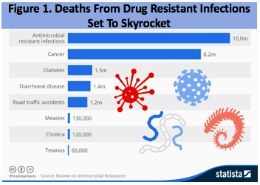
Assessing the frequency of antibiotic resistance in food-borne contaminants

We have entered the post-antibiotic era.
Every 11 seconds, someone in the US gets an antibiotic resistant infection and every 14 minutes, someone dies from that infection (1). As revealed in Figure 1 the World Health Organization has predicted that by 2050, infectious disease will be the greatest killer on the planet, accounting for over 10 million deaths per year and far exceeding deaths due to cancer (2).

Antibiotic use is linked to resistance.
Exposure to an antibiotic kills sensitive bacteria but selects for growth of organisms that are resistant to that drug. Resistance is a trait caused by heritable changes in the DNA. Genes encode products that confer resistance, such as enzymes that inactivate antibiotics or pumps that transport the antibiotic out of the cell, lowering the effective concentration inside the bacterial cell. These genes can be transferred from one bacterium to another, even between different species. To make matters worse, multiple resistance genes often cluster together, and when that fragment of DNA is transferred between bacteria, a single event can confer multidrug resistance, resulting in superbugs.
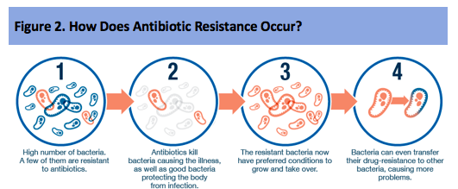
As shown in Figure 2, the presence of antibiotics kills bacteria that do not harbor resistance genes; however, it selects for survival of those that do (3). Therefore, any environment with high levels of antibiotics is likely to harbor high levels of antibiotic-resistant bacteria. It is a simple equation: more drugs select for more bad bugs, or “superbugs”. Superbugs are bacteria that are resistant to multiple antibiotics.

How Antibiotic Resistance Connects to Food Safety
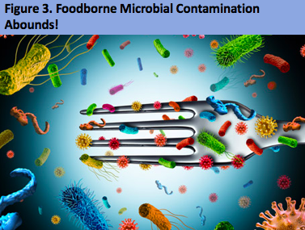
Antibiotics are used to prevent, treat, and control infections in animals, including food animals. They are also used to promote growth. Animals, like people, carry bacteria in their intestines. When food animals are given antibiotics, resistant bacteria in their intestines can survive and grow. These resistant bacteria in food animals can contaminate meat and poultry, enter the local environment through animal feces, spread to fruits and vegetables being grown nearby or into irrigation water used to water plants. As Figure 3 suggests people can get infected by handling or eating raw or undercooked meat and poultry or eating contaminated fruits and vegetables or coming into contact with animals or animal feces - either by directly touching it or through irrigation water, drinking water, or recreational water (5).

Assessing the frequency of antibiotic resistance in food.
This laboratory engages you in a project focused on determining the frequency of antibiotic resistance in bacterial food contaminants. The target of this screening effort is Escherichia coli (or E. coli), which is a major food contaminant associated with raw or undercooked ground beef, unpasteurized milk, unpasteurized juice and leafy greens (spinach, lettuce, sprouts, etc.). Each year in the United States, E. coli infections cause approximately 265,000 illnesses and about 100 deaths (4). You will determine which food source you wish to sample and then perform a screening study to determine if E. coli is present and, if so, is it harboring antibiotic resistance. This exercise is part of a larger program in the Riley lab designed to track antibiotic resistant E. coli in food. The data you generate will become part of the raw data for this long-term survey. That means that your data may end up in a scientific publication, depending upon your attention to employing proper controls and ensuring adequate replication. We will discuss this in more detail in class, but it is important that you realize that this is not simply a cook-book lab. You will be generating publishable data!

Isolating and detecting E. coli in food.
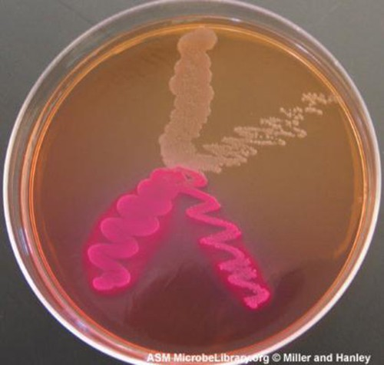
After you obtain food samples and determine if bacterial contaminants are present, you will need to identify if any of the contaminants are E. coli. This is accomplished by growing the contaminants on selective medium (MacConkey), which permits growth of the target species and inhibits the growth or differentiates in some way, the non-target species. Figure 4 provides an illustration of how MacConkey is used to differentiate E. coli based upon colony color. On this MacConkey agar plate, the lactose-fermenting E. coli colonies are bright pink. Serratia marcescens, which does not ferment lactose, forms a cream-colored streak in the tan medium.

Figure 4. MacConkey growth medium used to distinguish E. coli.

This research project will take place over 3 weeks. Figure 5 provides a flow chart of laboratory activities, which include:
- Week 1. Learn how to dissect a research article, learn microbiological techniques, form research teams, design your study, and obtain food samples;
- Week 2. Determine the frequency of bacterial contamination in food samples and identify E. coli;
- Week 3. Determine the frequency of antibiotic resistance in E. coli contaminants;
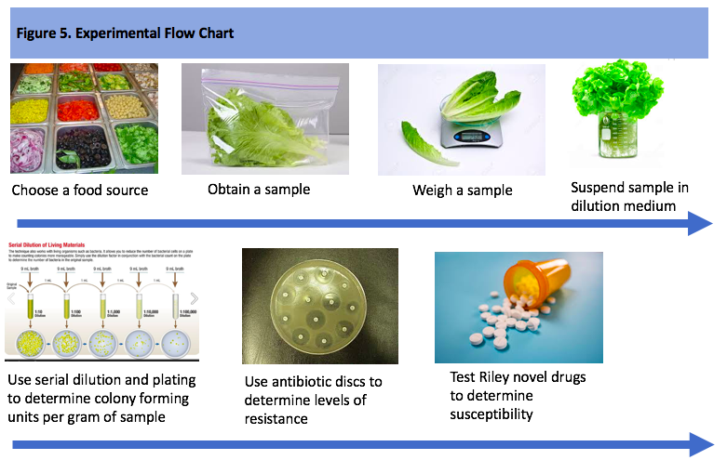

Present results in poster presentation

Before you start this lab, watch the video found at this link, which will provide a brief introduction to the topic of antibiotic resistance.

Laboratory 1. Introduction to Antibiotic Resistance

Introduction.
We will start with a mini-lecture from Prof Riley about the topic of antibiotic resistance. You will also learn about the importance of keeping a well-documented laboratory notebook as you learn some basic microbiological techniques. Next, you will be assigned to a research team and have time to brainstorm about what food items you wish to sample in your hunt for antibiotic resistant E. coli.

Goals.
Students will master the following:
- Learn about the antibiotic resistance health challenge;
- Learn about how to keep a well-documented laboratory notebook;
- Engage in team-based brainstorming to choose food articles;
- Culture bacteria and discriminate between E. coli and other bacterial food contaminants;
- Practice microbiological laboratory techniques;
- Discuss how to read a primary research article.

Materials needed
- laboratory notebook
- paper copy of lab manual
- pen and permanent marker
- LB and SE plates
- EC = Escherichichi coli cells
- SA = Staphylococcus epidermidis cells
- sterile beads and waste receptacle for used beads
- pipettemen and sterile tips and waste receptacle for used tips
- antibiotic disks
- forceps
- parafilm and scissors
- Zip lock bag (each student)
- Plastic gloves (each)

Methods
- Laboratory notebooks. We will discuss how to keep a laboratory notebook - make sure to have yours with you - ALWAYS BRING IT TO LAB.
  - Place your name on the front cover
  - Label the first page: Table of Contents
  - Label the second page with the date and Antibiotic resistance lab #1.
  - Create a section label: Introduction to antibiotic resistance by Prof Riley.
- Introduction to antibiotic resistance. You will listen to Prof Riley’s mini-lecture about antibiotic resistance. Be prepared to take notes as you listen (in your lab notebook) and identify 3 questions to ask about the material. Write these questions down in your lab notebook.
- Practice techniques. Pairs of students will practice the techniques that will be used in screening their food samples next week. Each pair will work together to produce the 4 plates described below.
  - In your lab notebook, draw a simple flow chart of the steps you will engage in next. An example of a flow chart for this section is provided in Figure 6.
  - In the future - you will create a flow chart BEFORE each lab period to ensure you are ready to dive into the research when you arrive at lab.
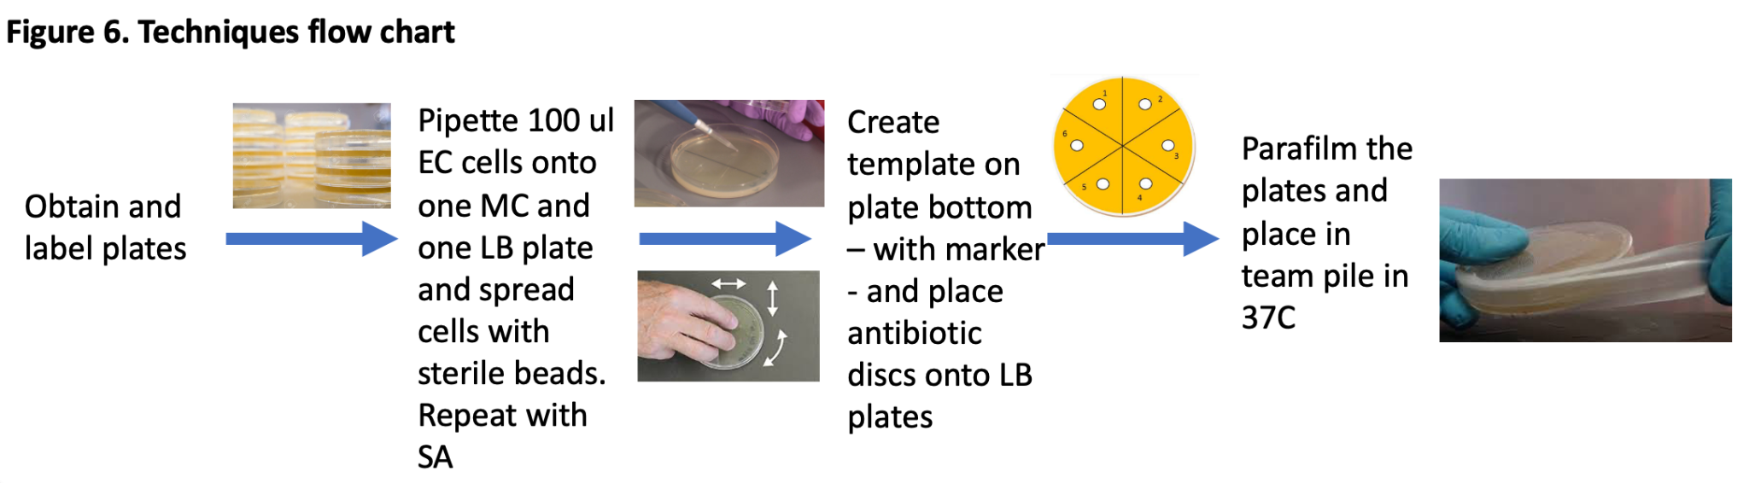

  - Create a results table (see Table 1) to record your results next week. You will prepare a results table before you start an experiment. This is done BEFORE each lab period to ensure you understand what data that day's experiments are meant to produce.

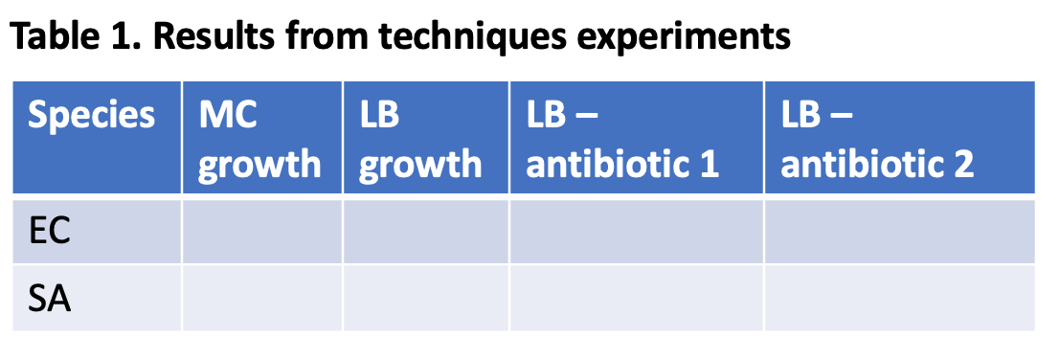
  - Each pair of students should label two LB and two MC plates with initials, the date, and the species (EC or SA) - on the bottom plate (the side with agar in it). DO NOT LABEL ON THE TOP - in case your lid comes off. You want one set of plates (LB and MC) for the E. coli sample (EC) and one set of plates (LB and MC) for the S. aureus sample (SA).
  - Pipette 100 ul of bacterial cells onto the appropriate plates.
  - Tap 5 or so sterile beads onto each plate and swirl the plate to spread the cells and create a lawn of bacteria. Swirl for 30 seconds with a back and forth motion, then twist the plate 90 degrees and repeat. These actions will ensure that you obtain a well spread “lawn” of bacterial growth.
  - You should now have
    - One LB plate with EC cells
    - One LB plate with SA cells
    - One MC plate with EC cells
    - One MC plate with SA cells
  - Draw a template on the bottom of the LB plates for your antibiotic disks. One template might look like you are slicing an agar “pie” and you should have one slice of “pie” for each disk.
  - Use forceps to carefully place the antibiotic discs on the LB with EC and LB with SA plates. Make sure that the discs are evenly spaced. Then gently tap the discs to ensure they are stuck to the agar.
  - Use parafilm to seal your plates and leave on the bench turned upside down - bottom of the plate on top - to avoid condensation falling onto the agar. Your TAs will gather the plates and place them in 37C for 24 hours, remove them, take photos and place plates in 4C for you to view next week.
- Dissect a scientific article. Your TA will walk you through the process of reading a scientific article. The focal article can be found at DOI: 10.1089/fpd.2020.2792739. If you are unable to access the file - a PDF is available on Moodle.
- Brainstorm about food sources. Your final task for the day is to come up with a testable hypothesis related to antibiotic resistance in food. Based upon the prior activity (step 4) you will already be familiar with what a testable hypothesis is. In this activity, since we have very little lab time available, your hypothesis must be ridiculously simple, so that we stand a chance of actually testing it in the two remaining lab periods. However, just because it is simple, does not mean it isn’t worth doing.
  - Create Table 2 (see sample below) in your lab notebooks and come up with a minimum of two ideas. Be sure to fill in each of the required boxes in Table 2.
  - If time permits - you will choose your favorite idea and briefly present the hypothesis to the class.
  - FUN FACT. Last year, one team decided to test pasteurized versus unpasteurized milk. One would assume that pasteurized milk would be sterile - right? After all, that is the point of pasteurisation. You might think that is a silly experiment to propose. Well, these students obtained pasteurized milk from the dining hall - and low and behold - it had enormous numbers of colony forming units (CFU) - which means it was heavily contaminated with bacteria! The team was so excited about their data, that they ended up performing repeated experiments throughout the semester, on their own time, to figure out how the milk could have ended up so contaminated. One of your TA’s, Sean Sullivan, graciously helped them out - if you are interested in how the story ended - speak with Sean!

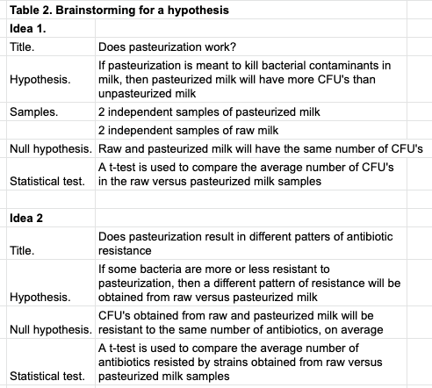

- Be sure to take plastic gloves and ziploc bags for obtaining your food samples. Store at an appropriate temperature until you can bring them to the lab.

Assignments
- Procure food source. Each student in the team will obtain a separate sample of the target food source, preferably at different times or from different locations to ensure a diverse sample of that food.
  - Use gloved hands to place your food sample into the zip lock bag. Avoid contamination with your skin.
  - Label the outside of the bag with your name, the food source, and collection date.
  - Store your sample at 4C or bring it to the lab for storage.
- Read the manual for Laboratory 2. Prepare a flowchart and results tables as required.

________________________________________________________________

Laboratory 2. Screening a food source for E. coli contamination

Introduction. Our goal is to determine the frequency of E. coli contamination in the food source you obtained. To do this, we need to know:

- The total number of bacterial cells present in the food;
- How many of those cells are E. coli.

A standard method for estimating the number of bacterial contaminants in food is to determine the number of colony forming units (CFUs) per gram or milliliter of food. In this project, cell numbers are estimated by spreading a known volume of your food sample onto plates containing nutrients for bacterial growth. When individual bacterial cells land on the growth medium, the cells undergo divisions to produce a colony visible by naked eye. Counting the number of CFU’s that grow provides an estimate of the number of cells in your original food sample. The values obtained are estimates because cells that are dead or cannot grow under our particular growth conditions will not be detected.

You will need to weigh out a specific amount of your food sample and create a suspension of your food. The precise protocol will differ for each food source. If you sample lettuce, meat, cheese, or any other solid food, you will want to break up the food (perhaps by slicing it into small pieces or grinding it up) and get it into suspension (perhaps by vortexing it) to create your “neat” stock solution (neat means undiluted). We will use dilution medium (DM = saline) for this step. If you sample milk or other liquids, then that is your dilution stock (neat sample).

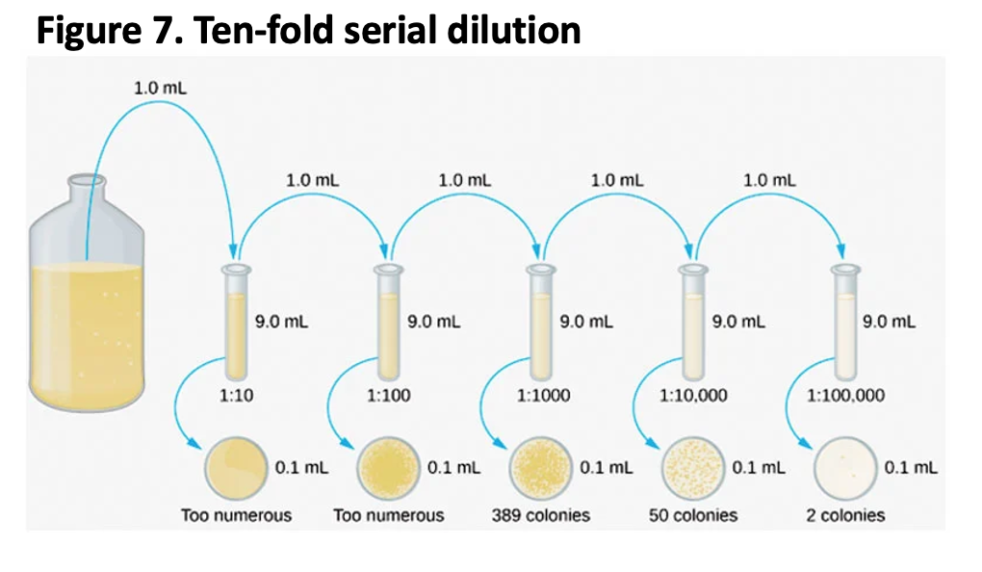
Once you have your food in suspension (“neat” stock), you need to sample this suspension to determine how many bacterial cells are present. We often have no idea how many cells are expected, so we assume that there will be a large number and create a serial dilution from this sample to ensure that we obtain a countable number of cells in at least one of our petri plates. Figure 7 shows an example of a serial dilution. In this lab we use test tubes with 9 ml of DM. We add 1 ml from our neat sample and vortex to mix the solution. This is a 10-fold dilution. You can repeat this dilution process (serial dilution) for as many times as you think might be necessary. Based upon prior experience we will assume that 2 to 3 dilutions (depending on your food source) will be sufficient to provide a countable dilution of contaminants.

Goals
Students will master the following:
- Learn how to sample bacterial contaminants in food;
- Learn how to perform a serial dilution;
- Gain additional experience with microbiological techniques; and
- Discuss the information provided in a primary research article;

Materials needed
- laboratory notebook
- paper copy of lab manual
- pen and permanent marker
- last weeks plates
- fresh LB and SC plates
- sterile beads and waste receptacle for used beads
- pipettemen and sterile tips and waste receptacle for used tips
- scale and weighing boats
- spatulas for handling foot items
- food sample
- sterile tubes with 9 ml DM
- sterile bottle of DM
- sterile 25 ml falcon tube
- scale (1 gm)
- scoop, scissors, spatula
- Ethanol
- Vortex
- Parafilm and KimWipes
- E. coli growth for control plates

Methods
- Find your plates from last week and fill out the appropriate table in your lab notebook. You want to note what the bacteria on the plate look like (color, size, shape, texture) and record if the EC or SA are resistant to any of the antibiotics tested. The class will discuss these results.
- While you are scoring your plates, the TA’s will examine your lab notebooks.
  - They will check your notes from last week’s meeting and make sure that you prepared a flow chart and results table for this week's lab.
- Teams will next decide how to pool their food samples for dilution plating.
  - If you sampled a solid food source
    - Each team will then measure 1g of food using a sterile spatula or forceps (clean with ETOH and Kimwipe prior to use) and place that food into a sterile 25 ml bottle with a cap.
    - Add an appropriate amount of dilution medium (DM) to permit suspension of the food in the DM – often 10 ml is sufficient - but keep track for later calculations. You may need to adjust the grams of food and/or the volume of DM to get your particular food source into suspension.
    - Make sure to vortex the sample to ensure all bacterial contaminants get into your solution. Keep track of the grams of food and the volume of liquid as this is critical information in determining the CFU’s per gram of food.
  - If you sampled a liquid, then that is your “neat” solution and you are all set for the next step after you pool the team's liquid samples.
- Each pair of students will start by creating your control dilution and plates
  - Take 1 ml of E. coli control cells (neat sample) and place it into a test tube with 9 ml of DM, vortex vigorously to ensure adequate mixing (that is a 10-fold dilution of your original sample).
  - Take 1 ml from this 10-fold dilution test tube and place into a fresh tube with 9 ml of DM, vortex vigorously to ensure adequate mixing (that is a 100-fold dilution of your original sample).
  - Repeat for 5 total dilutions.
  - Each pair will label 1 LB plate for each dilution (neat, 10-fold, 100-fold, 1000-fold, 10,000, and 100,000). Note the dilutions on the plates.
  - Use a sterile pipet to transfer 0.1 ml of the neat E. coli growth onto the LB plate labelled for neat and spread the cells with sterile beads.
  - Repeat the plating step for each dilution (10-fold, 100-fold, etc.). Each pair should have a total of 6 plates at the end.
- Each pair will repeat this dilution and plating procedure for your food source, this time using only 3 dilutions, plus the neat sample.
  - You must use both LB and MC plates so we can identify which CFU’s are E. coli.
  - Each pair should have a total of 8 plates at the end (4 LB and 4MC).
- Wrap all plates with parafilm and place in 37C incubator.
  - You MUST return in roughly 24 hours to remove plates from the incubator, photograph them and place them in 4C (refrigerator).
- Be sure to save your neat food sample - in case your plates are not countable.
- The class will work together to predict the density of the E. coli control cells, with the starting information that an overnight growth of E. coli should reach 1x10⁹ cells per ml.
- If time permits - the class will work through a second research article.

Assignments
- Each student will
  - Identify one article from the primary literature related to your food source, E. coli, and antibiotic resistance.
  - Read the article and prepare a 3 min summary for use during your team meetings.
  - This summary should be written in your lab notebook.
  - Be sure to provide a reference in your lab manual for the article.
- Read manual for Laboratory 3 and prepare flowchart/tables for next week’s lab

________________________________________________________________

Laboratory 3. Counting CFU’s and Screening for Antibiotic Resistance

Introduction
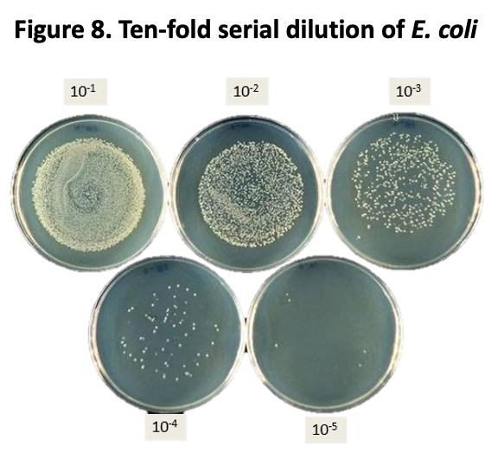
This week you will determine if your food samples were contaminated and, if so, how many of the contaminants are E. coli. An example of the results from a serial dilution plating of E. coli is provided in Figure 8. You want to choose the plate that has between 50 and 300 colonies to count. In this example you would count the 10⁻⁴ dilution plate.

Your next task is to determine the frequency of antibiotic resistance among your sample of E. coli strains. To do this, you will create lawns from each strain of E. coli you choose and then place antibiotic impregnated discs onto the lawns of each strain.

Goals
Students will master the following:
- Gain experience creating and using a spreadsheet to calculate the number of CFU’s per gram of food;
- Gain experience using antibiotic discs to determine a strain’s sensitivity to a battery of antibiotics;
- Gain additional experience with microbiological techniques; and
- Work as a team to identify an appropriate research article that addresses some aspect of your team's experiment.

Materials needed
- serial dilution plates from last week
- neat food sample
- LB plates - 5 per person
- antibiotic discs - 5 per person of each antibiotic
- markers
- forceps
- sterile swabs and waste swab container
- sterile glass beads and waste bead container
- parafilm
- E. coli control growth

Methods
- Arrange plates from your dilution series as shown in Figure 8. Make sure that you photograph your dilution series and put those photos into your lab notebook.
  - E. coli control serial dilution
  - Food contaminant serial dilution
- Scan the plates to assess whether there are any obvious errors in the dilution or plating technique.
  - Each plate should have about 10-fold fewer colonies than the plate to its immediate left. If this is not the case, record that information and propose a reason why this might be - record that thought process in your lab notebook.
  - For each food sample and plate medium, determine the most “countable” plates (plates with 30-300 colonies). Figure 8 provides an example of a countable plate (the 4th plate in the serial dilution series).
- Count the number of CFU’s on the countable LB and MC plates - each plate is counted twice to reduce human error.
- Your TA will work with you to create an excel spreadsheet in which you will enter your CFU counts and then calculate the CFUs per gram of food, the E. coli CFUs per gram of food, and the relative number of E. coli versus all other CFUs per gram of food, taking into account the dilution of the plate that you counted. Once you have completed this step you will share your results with the class.
- Now you must determine how many E. coli strains you will sample to determine antibiotic resistance frequencies. You may consider each pink CFU on your MC dilution plates as a unique E. coli strain.
  - You want to create a sample large enough to have some statistical meaning, but small enough so you can complete your screen during this lab. About 20 strains per team is a reasonable target number.
  - This time you must consider what will be your positive and negative controls. As you will have discussed in the lab - the controls are chosen to ensure that your treatment (and experimental procedures) are working properly. The treatment is the exposure of the cells to antibiotics - so you must identify controls to ensure they are able to kill sensitive cells and not kill resistance cells. Think back to your results from last week's experiment and decide what might serve as controls.
- Refer to your flowchart to screen your strains for antibiotic resistance.
- For each strain, use a sterile swab to create a lawn on an LB plate. To do this, touch a sterile swab to the colony, then use that swab to spread cells across the entire surface of the plate. Make sure that you swab your cells back and forth in multiple directions to ensure a solid lawn covers the plate.
- You will then place each of the antibiotic discs on the plate using sterile forceps using a template pattern that your team agrees upon.
  - Make sure to create a standard template on your plates that all members of the team will employ on their plates.
- Parafilm your plates and leave them inverted on the bench.
  - You must make time to come back to the lab in 24 hours to photograph your plates and measure zones of inhibition. Rulers will be available in the lab.
  - For each disk - measure the zone diameter. If there is no zone, then the cells are resistant to that antibiotic.
  - Score your disk measurements in your lab notebook and in the lab’s central data spreadsheet.
  - You will score your strains as sensitive or resistant according to Table 3, which is available as a PDF on Moodle.
- Teams will spend time sharing what they learned from their research articles and vote on which article is most useful for their study.

Assignments
- Read the team’s chosen research article
- As a team: Prepare a 3 min presentation for the class that incorporates your data and compares it in some way with the article you read. The format of your presentation is as follows:
  - title slide: Name of Team and student names, Name of Study, Some sort of relevant image - perhaps the food source?
  - slide 2: introduction to the topic - use visuals and bullets NOT sentences or long strings of text
  - slide 3. results - summarize your results in some easy to visualize way - don’t just paste a table onto a slide - perhaps use a figure or chart to present your data visually - can be more than one slide if needed.
  - slide 4. interpretation of your results - explain what you make of your data and bring in the article you read - can be more than one slide if needed.
  - slide 5. Provide references for any resources you used and describe what each student did to create the presentation.
Don’t forget to practise your presentation before the next lab meeting.

References
1. Centers for Disease Control and Prevention (U.S.). Antibiotic Resistance Threats in the United States, 2019. Centers for Disease Control and Prevention (U.S.), Nov. 2019. DOI.org (Crossref), doi:10.15620/cdc:82532.
2. Coles, Derrick. “How Does Antibiotic Resistance Occur?” Resistance Is Futile, http://modmedmicro.nsms.ox.ac.uk/learn-more-about-antibiotic-resistance/. Accessed 10 Jan. 2021.
3. Escherichia Coli (E. Coli) Infection. NC Department of Health and Human Services, https://epi.dph.ncdhhs.gov/cd/diseases/ecoli.html. Accessed 10 Jan. 2021.
4. No Time to Wait: Securing the Future from Drug-Resistant Infections. Report to the Secretary General of the United Nations. Interagency Coordination Group on Antimicrobial Resistance, Apr. 2019, p. 28.
5. Rohan, Alicia. What’s Making You Sick: An in-Depth Look at Food-Borne Illnesses. 13 Oct. 2017, https://www.uab.edu/news/youcanuse/item/8792-what-s-making-you-sick-an-in-depth-look-at-food-borne-illnesses.

